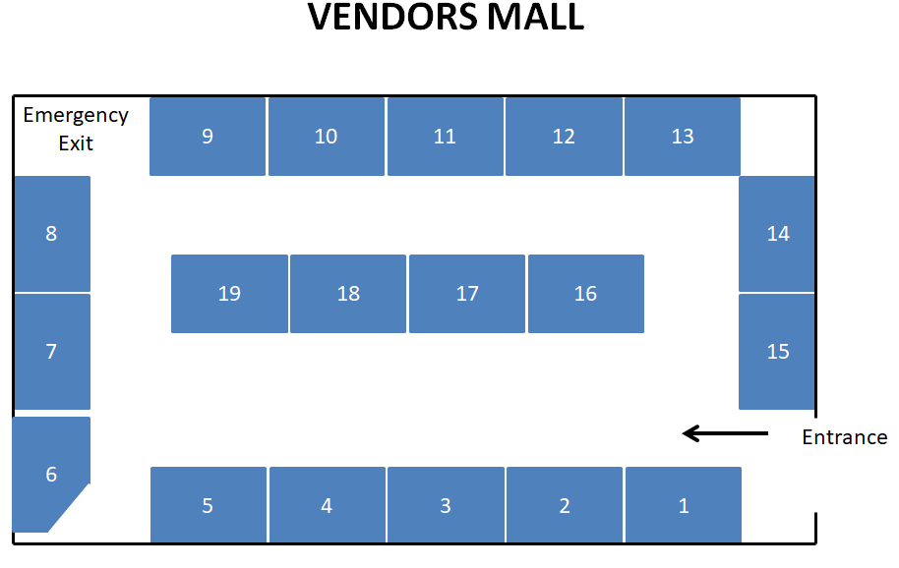

————————————————————————————————————————————————————————————————————————

A celebration of quilting and textile art as a medium for promoting environmental awareness.

————————————————————————————————————————————————————————————————————————



